Igiit admin

company->edit: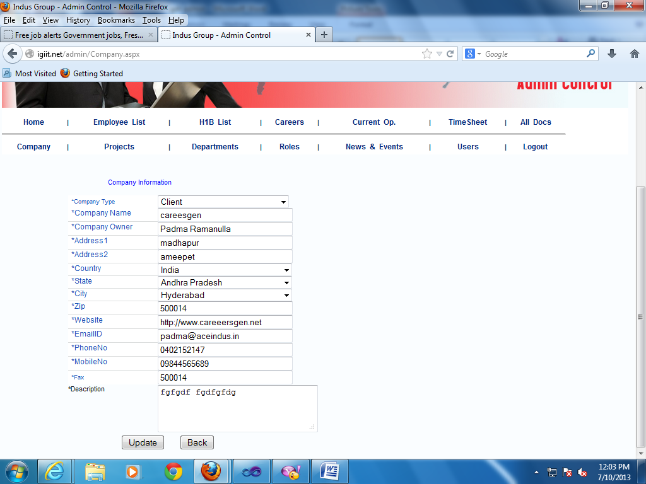

Mobile num accepting more than 10 digits.&

Width of this drop down list is less when compare to all.

Employeelist->view: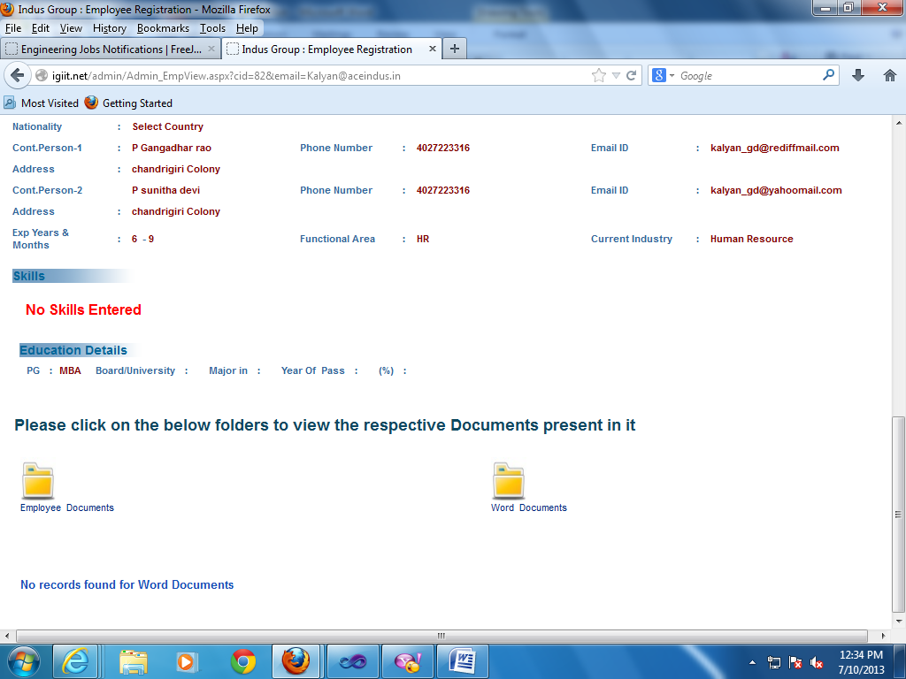

This button is not working.

Employeelist->editempid: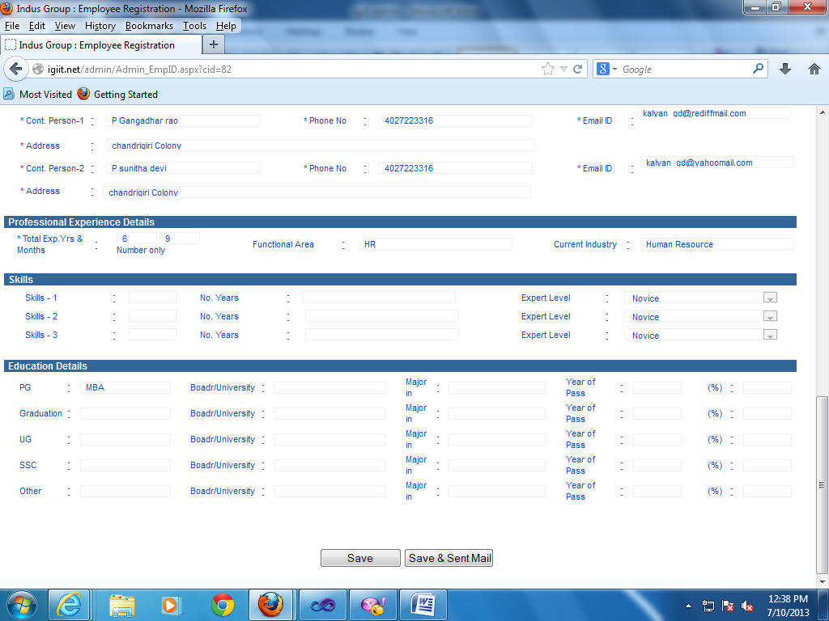

These button are not working& entire form is in read only mode except Empid.

Employeelist->view: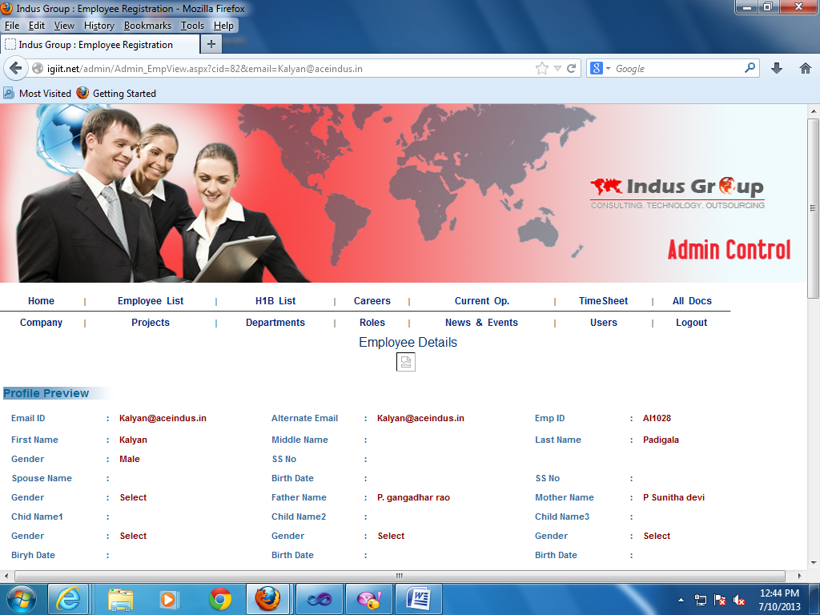

Image not displaying.

Employeelist->edit: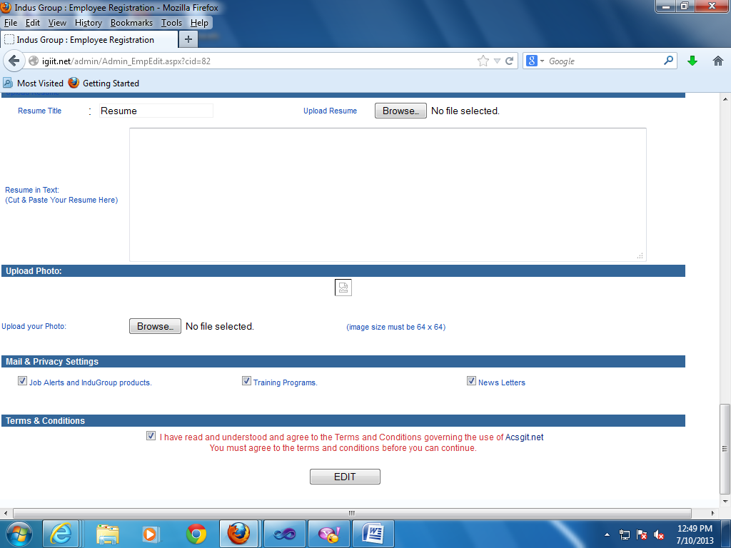

Image not appearing.

All docs: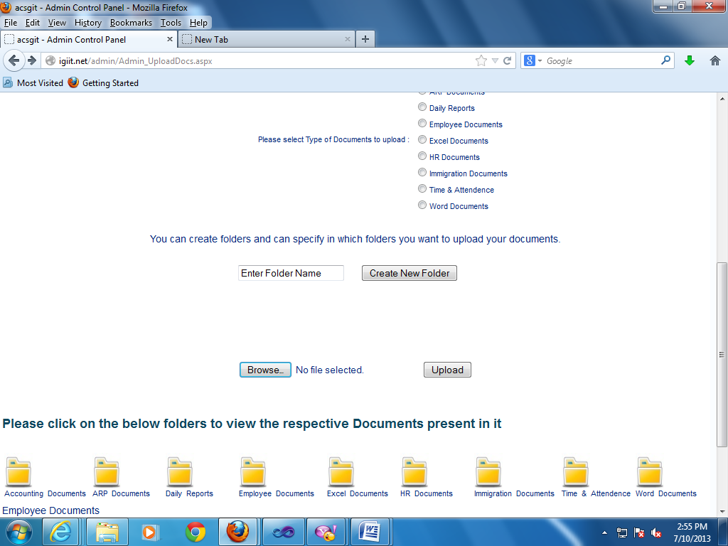

If we upload any file error is coming like below.

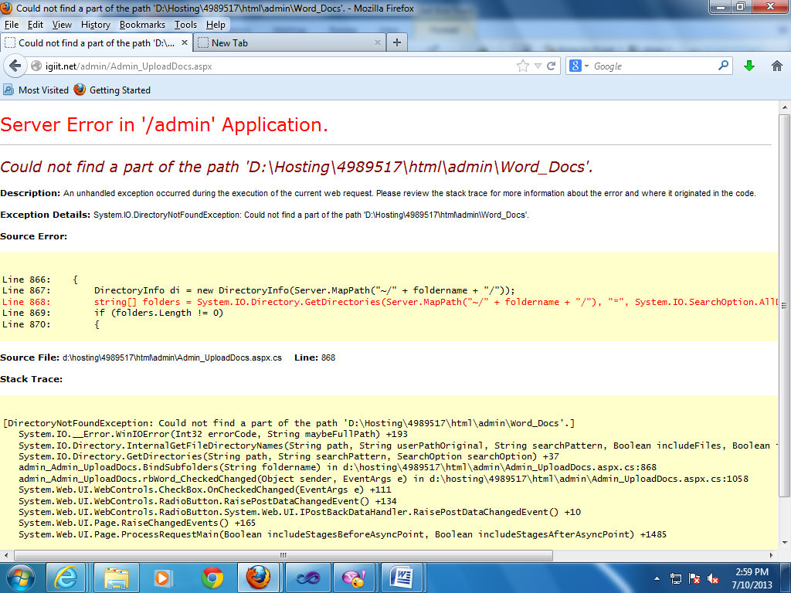

users->create new user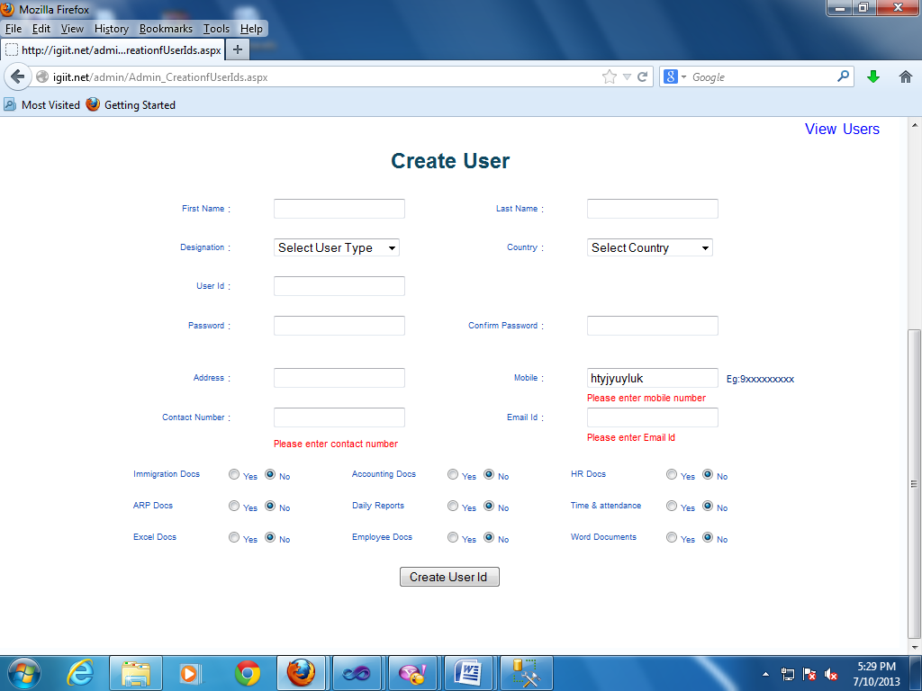

Mobile num is accepting characters also

Users->create new user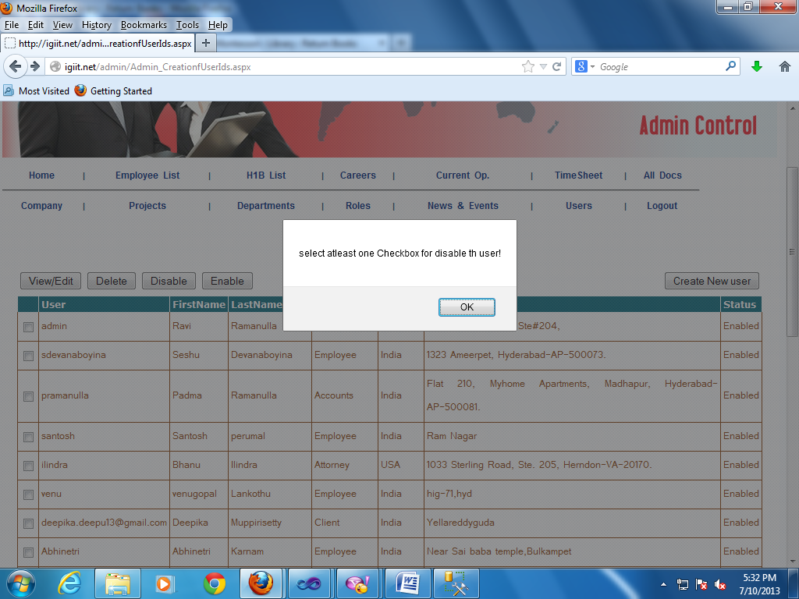

Spelling mistake at ‘the’.

Departments->new: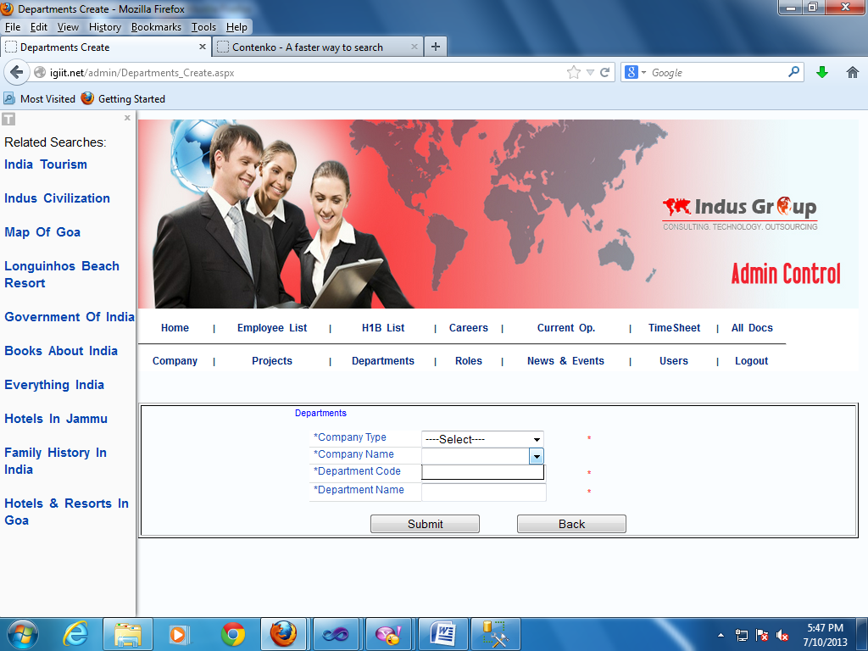

Projects: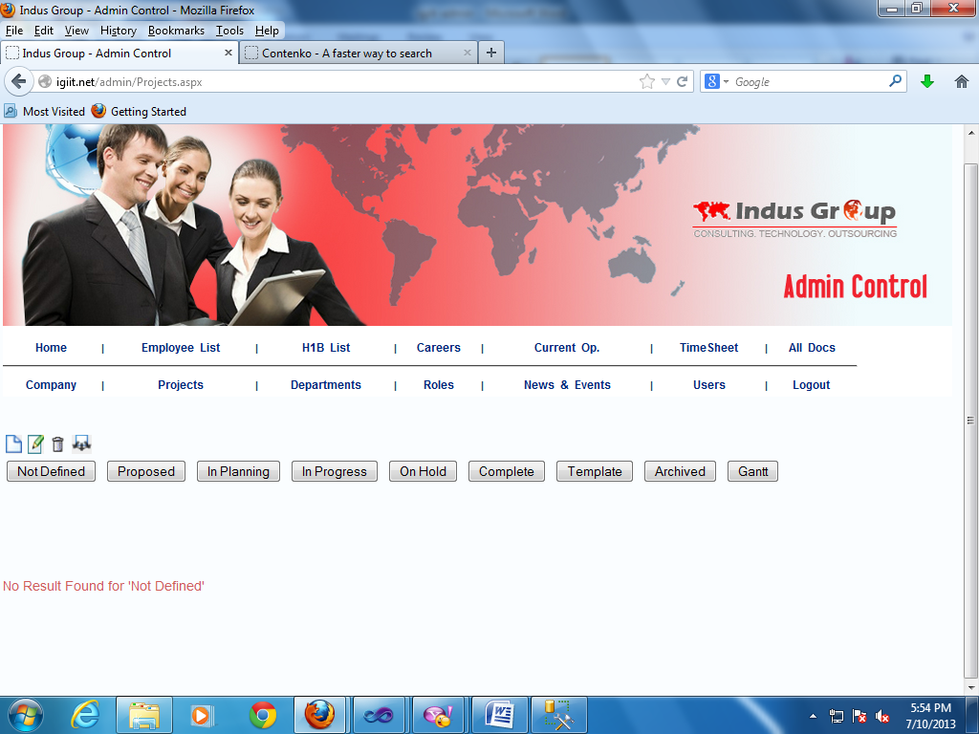

By default this text is coming

Employeelist: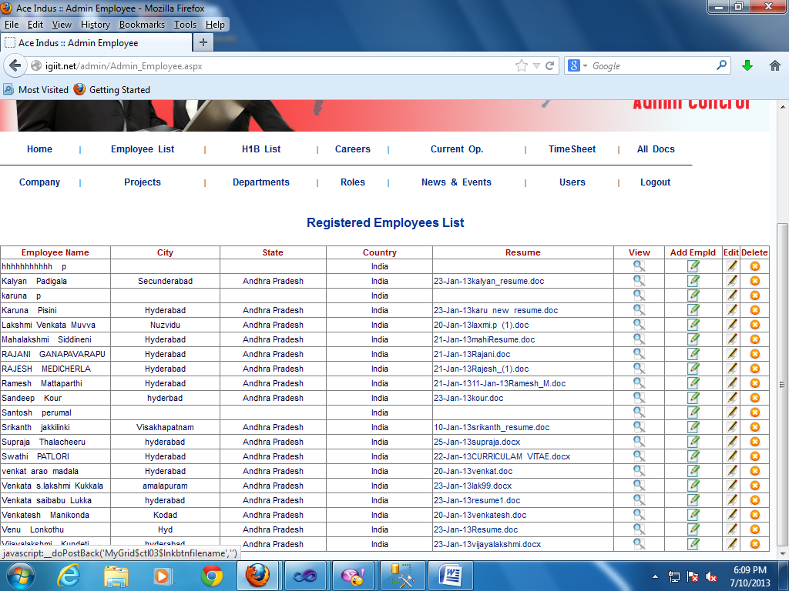

If we click on these resumes resume is not downloading .